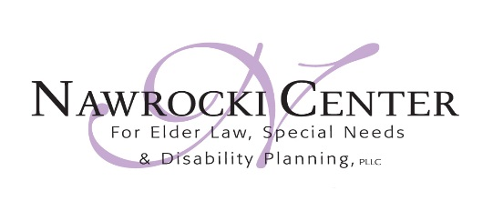

Livingston County Commitment to Caring Award
Nomination Form
The Livingston County Commitment to Caring Award is an annual award presented by the Livingston County Consortium on Aging and sponsored by the Nawrocki Center for Elder Law, Special Needs, and Disability Planning. The award is intended to honor an individual or organization that has consistently demonstrated commitment, care, and service to the Livingston County senior community on an ongoing basis.
This award is presented by the Consortium at its Senior Celebration each year in August/September. The award consists of a handsome trophy, and a $500 contribution from the Nawrocki Center to a charity or service organization selected by the awardee.
Criteria for the award: An ongoing history of commitment, care, and service to the Livingston County senior community as demonstrated by specific actions and contributions. The awardee will be selected by Consortium member organization representatives from submitted nominations.
To submit a nomination, please complete this form by July 9, 2021 and submit to the Consortium on Aging:
Mail to: or Scan and Email to:
Livingston County Consortium on Aging LCCOA48843@gmail.com
UPS Box 142
4337 Grand River
Howell, MI 48843
I wish to nominate ______________________________ for the Livingston County Commitment to Caring award.
The reason my nominee deserves this award:
_______________________________________________________________________________________________________________________________________________________________________________________________________________________________________________________________________________________________________________________________________________
Nominated by: Name___________________________________________
Phone number (if further information needed): _______________________

