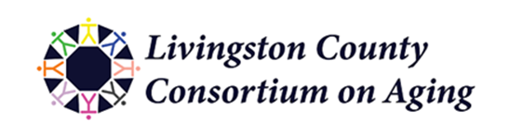
To Livingston County Organizations Positively Impacting the Aging Population,
You are receiving an invitation from the Livingston County Consortium on Aging to apply for the 2023 Grant Cycle. The Livingston County Consortium on Aging was established for collaboration, advocacy and communication between agencies and persons concerned with the provision of services to all older adults in our community. Through our efforts in the community providing two long standing events, The Annual Caregiver Fair and The Livingston County Senior Celebrations, we are able to provide grants to local non-profit agencies that serve our Livingston County Seniors. In the past few years, LCCOA has been able to gift thousands of dollars, to organizations who used the gift to provide programs, services, and equipment to aging adults in Livingston County. We know that there are many unmet needs and priorities in the county and feel fortunate to be able to provide a small gift that will positively impact one or more areas of the community through:
● Active Aging (geriatric services, health and fitness opportunities)
● Aging in Place (safe, affordable housing, either in their own(ed) home or communal)
● Community Engaging Seniors (keeping them involved, and regarded as valued)
● Community Infrastructure (gathering spots, transportation, health care, food)
You may be as creative as you wish in interpreting how you will use this up to $1000 gift to influence the need of your organization. The evaluative committee is comprised of anonymous consortium members who donate their time and take on this project seriously, with the singular goal of benefiting Livingston County seniors.
Applications will be accepted both virtually, through the attached link, as well as physically by submitting a document to our UPS box. Also included in this packet are the criteria that the Evaluation Committee will use to assist in the awarding process. Please note that the deadline for submission is February 21, 2023 at 5pm - Submissions must either be in hand at the 4337 Grand River, UPS box 142, Howell, MI 48843 or submitted virtually on or before February 21st at 5pm.
It is the LCCOA’s ultimate goal to award as many grants as possible, potentially rewarding a mix of full and partial grant requests that is to the discretion of the evaluation committee. The LCCOA thanks you for your efforts on behalf of county seniors and hopes to be hearing from you. Please feel free to contact me if you have any questions.
Sincerely,
Marie Verheyen
Grant Chair (248) 209-2671
The Livingston County Consortium on Aging
Note: If applicable, applications for grants from previous successful recipients will not be accepted unless a final report has been filed from your last grant.

